

Smart Visit Card (SVC)
An Android-Based Application for Managing Visit Cards
Authors:
Miras Safadi 315891549
Rani Hassan 315060103

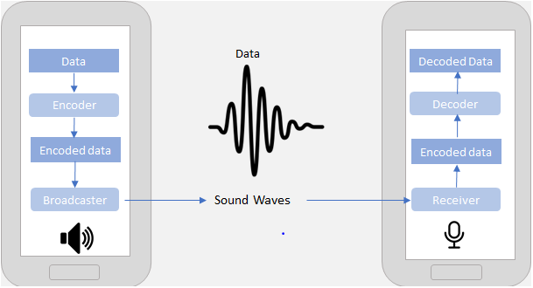

Supervisors:
Dr. Dan Lemberg
Dr. Elena Ravve
Contents
1. Introduction 3
2. Background and Related Work 5
3. Smart Visit Card Transfer 9
4. Example of Data Preparation for Inaudible Transfer 16
5. General Flow of Data Preparation for Inaudible Transfer 19
6. Difficulties and How We Overcame Them 21
7. Results and Conclusions 24
8. Preliminary Software Engineering 24
9. References 36

- Introduction
One of the possible problems that one faces when her/his lifestyle imposes on her/him is the burden of being in touch with many people of many professions and carrying a lot of visit cards and carrying a stack of her/his own visit card to give to people. With the recent up rise in technology, one would only think of how to take advantage of that up rise to their favor.
The aim of this project is to manage all those visit cards we carry around with us. With this application, you can store that stack of visit cards you carry around with you in one accessible, convenient place. In fact, the contacts are automatically transferred directly to the phone book of the cellular phone and stored in a database residing in the phone.

  - What We Did?
The main objective for this project is to create an Android based application for managing visit cards that is easy to use, reliable, and fast. The user should be able to get the full functionality of the application the first time she opens it without any special instruction or guidance. Ease of use is a primary objective because the app should be easy to use without making users read an instruction manual or go through any training.
Since the application is most likely to be used by non-developers, reliability is the key issue. A range of users at varying levels of technical knowledge should be able to use the application without it crashing or having erratic behavior.
To achieve that, first, we did a field research and went through dozens of visit cards. Then, we chose which contact information is most common. Next, with the results of that field research we created a user-friendly GUI for our app. Moreover, our implementation enables the user to manage her/his visit cards in a CRUD manner (Create, Read, Update, and Delete). In addition, we proposed and implemented an encoding and decoding method, which allows significant compression of the visit card information. Another team of students implemented a smart voice-based transfer of the information between Android based devices.
In fact, we concluded from our preliminary research (we will provide more information in the upcoming sections) that the most common contact information is:
- Name
- Position title
- Company
- Address
- Telephone
- Fax
- Mobile
- Email
- Website

  - List of functionalities:
List of the functional units:
- Registration
  - User can register or login to the app with his/her email and password.
- Main
  - List of visit cards the user has collected.
  - Buttons: user profile, creating a new visit card, edit an existing visit card.
  - Tapping on a visit card will open the details of said visit card.
- User Profile
  - User can update her/his password.
  - Apps settings: sign out button.
- Create A New Visit Card/ Edit an existing Visit Cards
  - Details of every visit card will contain:
    - Name (prefix + first name + middle name + last name)
    - Position title
    - Company
    - Address
    - Telephone
    - Fax
    - Mobile
    - Email
    - Website
  - Update details of existing visit card.
  - Delete visit card.
  - Why Is It Not Trivial?
Our project is an application for cellular phones, based on Android OS. It is a new development area for us, in which we had no prior experience in. We had to deal with this development area and learn how it works and understand how Android based applications work "behind the scenes", to use its’ features. In addition, we had to study, design, and implement an algorithm for encoding and decoding visit card information.
Moreover, we studied how an Android application connects to a local database because our application saves newly created visit cards to a local database, which resides in the phone.
  - How We Overcame the Challenges?
First, we investigated in which languages can an Android application be written and found out that it can be written in either Java or Kotlin. Given that we are already familiar with Java and that it would take time to learn a new language, we chose Java over Kotlin. Next, we went to the official documentation of Android OS [1] and studied it. With each step we took in the implementation phase and with each problem we faced we visited many websites [2] for help and guidance.
Finally, we studied how we could connect our app to a local database and found out it is possible to do so with SQLite database [3] which stores information on a text file on the phone.
- Background and Related Work
  - Basic terms definitions:
    - Smartphone
Smartphones are a class of mobile phones and of multi-purpose mobile computing devices [4]. They are distinguished from feature phones by their stronger hardware capabilities and extensive mobile operating systems, which facilitate wider software, internet (including web browsing over mobile broadband), and multimedia functionality (including music, video, cameras, and gaming), alongside core phone functions such as voice calls and text messaging. Smartphones support wireless communications protocols (such as Bluetooth, Wi-Fi or satellite navigation).
    - Visit Cards
Visit cards are cards bearing business information about a company or individual [5]. They are shared during formal introductions as a convenience and a memory aid. A visit card typically includes the giver's name, company, or business affiliation (usually with a logo) and contact information such as street addresses, telephone number(s), fax number, e-mail addresses and website. Before the advent of electronic communication visit cards might also include telex details. Now they may include social media addresses such as Facebook, LinkedIn, and Twitter. Traditionally, many cards were simple black text on white stock, and the distinctive look and feel of cards printed from an engraved plate was a desirable sign of professionalism. In the late 20th century, technological advances drove changes in style, and today a professional visit card will often include one or more aspects of striking visual design. Below, see Fig. 1 and Fig. 2, are some examples:

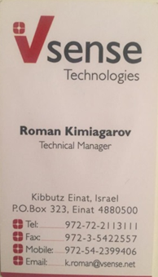


Figure 1 – Travel agent visit card.

Figure 2 – Personal visit card

SVC is designed to help people with managing visit cards with as little effort as possible. To do so SVC was based on the following Concepts, Technologies, Design Principles and Doctrines.
- Core Concepts
    - Compression
Compression [6] is the method, which computers use in order to make files smaller by reducing the number of bits (1’s and 0’s), used to store the information. Lossy compression makes the file smaller by getting rid of bits and hoping you will not notice. In images this can be done by looking at pixels next to each other. If they are similar, they are made to be the same. Once a file has been compressed using a lossy method, any bits that are lost cannot be recovered. With lossless compression the file is reduced without losing any quality so the original file can be restored. Generally, lossless compression will not be able to make a file as small as a lossy method.
    - Decompression
Decompression [7] is the process of restoring compressed data to its original form. Data decompression is required in almost all cases of compressed data, including lossy and lossless compression. Similar to compression of data, decompression of data is also based on different algorithms. Decompression is considered important, as compressed data needs to be restored back to standard state for usage. Decompression is widely used in data communications, multimedia, audio, video, and file transmissions.
    - LZ77 and LZ78 compression and decompression
LZ77 and LZ78 [8] are the two lossless data compression algorithms published in papers by Abraham Lempel and Jacob Ziv in 1977 and 1978. They are also known as LZ1 and LZ2 respectively. These two algorithms form the basis for many variations including LZW, LZSS, LZMA and others. Besides their academic influence, these algorithms formed the basis of several ubiquitous compression schemes, including GIF and the DEFLATE algorithm used in PNG and ZIP. We will use LZ77 as described in more details in Section 5.
They are both theoretically dictionary coders. LZ77 maintains a sliding window [9] during compression. This was later shown to be equivalent to the explicit dictionary constructed by LZ78—however, they are only equivalent when the entire data is intended to be decompressed.
Since LZ77 encodes and decodes from a sliding window over previously seen characters, decompression must always start at the beginning of the input. Conceptually, LZ78 decompression could allow random access to the input if the entire dictionary were known in advance. However, in practice the dictionary is created during encoding and decoding by creating a new phrase whenever a token is output.
    - API
An Application Programming Interface (API) [10] is a set of Classes and Methods which facilitate the development of application specific features.
    - Synchronization
Synchronization (or syncing) in computing is the process of ensuring that multiple copies of the same block of digitized information remain consistent across all synchronized sites.
In this project, we will refer to one-way synchronization, using the following terminology:
- Owner Site – A device which initiated the creation or alteration of a synchronized item.
- Server – Serves as a data store which synchronizes data between owner and replicated site(s).
- Replicated Site – A device which initiates a synchronization protocol with the server.
There are two kinds of synchronization protocol families:
- Full – synchronizes everything.
- Incremental – synchronizes only changed or newly added items.
Full Synchronization has a large network and computation overhead but is easy to implement. Incremental Synchronization on the other hand has a minimal overhead but can prove to be troublesome to implement. Full synchronization is still necessary though, as a first-time incremental synchronization.
- Software Development & Architecture Pre-Requisites
    - Basic software development & computer science knowledge
Reader is expected to be familiar with the following:
- Object Oriented Programing in the Java Environment.
- Parallel and Asynchronous Programing in the Java Environment.
- Networking Protocols and Java Programming in Networked Systems.
- Relational Databases and Schemas.
    - Distributed system architecture
A distributed system is a software system [11] in which components located on networked devices communicate and coordinate their actions by passing messages. The components interact with each other in order to achieve a common goal.
    - Client-Server architecture
The client–server [12] model of computing is a distributed application architecture that partitions tasks or workloads between the provider of a service (server) and the service requesters (clients). Clients and servers communicate over a network and run on separate machines.

- Android, Google & Facebook
    - Android OS
Android [13] is a mobile operating system (OS), cf. [14] based on the Linux kernel, cf. [15] and currently developed by Google. With a user interface based on direct manipulation, Android is designed primarily for touchscreen mobile devices such as smartphones and tablet computers, with specialized user interfaces for televisions (Android TV), cars (Android Auto), and wrist watches (Android Wear).
    - Android and SQLite
Every Android enabled device runs a SQLite database instance [16]. Applications can create relational schemas and use them for their purposes.
    - Android services
A Service [17] is an application component that can perform long-running operations in the background and does not provide a user interface.
    - Android Application
An Android application is a mobile application [18]. A mobile application is a computer program or software application designed to run on a mobile device such as a phone, tablet, or watch. Apps were originally intended for productivity assistance such as email, calendar, and contact databases, but the public demand for apps caused rapid expansion into other areas such as mobile games, factory automation, GPS and location-based services, order-tracking, and ticket purchases, so that there are now millions of apps available.
    - Android permissions
The purpose of permissions is to protect the privacy of an Android user [19]. Android apps must request permission to access sensitive user data (such as contacts and SMS), as well as certain system features (such as camera and internet). Depending on the feature, the system might grant the permission automatically or might prompt the user to approve the request.
    - Facebook API
The Facebook API [20] is a platform for building applications that are available to the members of the social network of Facebook. The API allows our application to use the social connections and profile information to make our application more involving.
- Server storage
    - Hypertext Preprocessor - PHP
Is a widely used open-source general-purpose scripting language [21]. PHP helps us to manipulate data on server side, get parameters from the client side and retrieve the manipulated data back to the client side.

    - Structured Query Language - SQL
SQL [22] is a special-purpose domain-specific language used in programming and designed for managing data held in a relational database management system (RDBMS), or for stream processing in a relational data stream management system (RDSMS). SQL helps us to better organize our data and visualize the relations between the object (tables) in our data, and which sub-object (column in a table) should do.
- Smart Visit Card Transfer
We explicitly declare here that the following section was done with collaboration with the second team. In particular, we worked together to write this section down to the specific details.
One of the main purposes of our application is preparation of information to be transferred to another cellular Android based device. That is why, here, we explain how information transfer works using voice channel of cellular devices.
  - How Smartphones Transfer Voice Data
In short, data-over-sound [23] enables the exchange of data between any devices with a pre-existing loudspeaker or microphone through sound waves. Delivered through machine-to-machine communications software, the technology works like an audio Quick Response code [24], sending data over an acoustic channel to enhance end-user experiences and add value to existing hardware.
In practice, data is encoded into an acoustic signal—a series of audible or inaudible pitches and tones to form a kind of “sonic barcode.” This is then played into a space (usually air but could be Voice over Internet Protocol [25] stream or wired telephone lines) and received and demodulated by a "listening" device. Data is subsequently decoded by the receiving device, or group of devices, and returns the original data.
By using a range of audio frequencies, programmers can fit more information into less audio. To filter out noise, developers carefully select frequencies and tune their software so that their applications can speak to each other to detect and decode data signals in noisy environments, like a busy train platform or concert venue.
    - Audio File Types
Each audio file type has unique benefits and drawbacks. Determine which one is best for specific tasks or situations to save time and reduce stressful errors. Here are six popular audio file types and some unique differences between them.
- Waveform Audio - WAV
A WAV audio file is a Waveform Audio File that stores waveform data [26]. The waveform data stored presents an image that demonstrates strength of volume and sound in specific parts of the WAV file. It is entirely possible to transform a WAV file using compression, though it is not standard. Also, the WAV is typically used on Windows systems.
The easiest way to envision this concept is by thinking of ocean waves. The water is loudest, fullest and strongest when the wave is high. The same holds true for the waveform in the WAV. The visuals are high and large when the sound increases in the file. WAV files are usually uncompressed audio files, though it’s not a requirement of the format.
- Audio Interchange - AIFF
AIFF is short for Audio Interchange File Format [27], which is an audio format initially created by Apple Computer for storing and transmitting high-quality sampled audio data. It supports a variety of bit resolutions, sample rates, and channels of audio. This format is quite popular upon Apple platforms and is commonly adopted in professional programs that handle digital audio waveforms.
- M4A
The M4A is a Moving Picture Experts Group (mpeg-4) audio file [28]. It is an audio-compressed file used in the modern setting due to increased quality demand as a result of cloud storage and bigger hard drive space in contemporary computers. Its high quality keeps it relevant, as users who need to hear distinct sounds on audio files will need this over more common file types.
Music downloads software like Apple iTunes use M4A instead of MP3 because it’s smaller in size and higher in quality. Its limitations come in the form of compatibility, as a lot of software are unable to recognize the M4A, making it ideal for only a select type of user.
- Free Lossless Audio Codec - FLAC
The FLAC audio file is Free Lossless Audio Codec [29]. It is an audio file compressed into a smaller size of the original file. It is a sophisticated file type that is lesser used among audio formats. This is because, even though it has its advantages, it often needs special downloads to function. When you consider that audio files are shared often, this can make for quite an inconvenience to each new user who receives one.
What makes the FLAC so important is the lossless compression can save size and promote sharing of an audio file while being able to return to the original quality standard. The near-exact amount of storage space required of the original audio file is sixty percent – this saves a lot of hard drive space and time spent uploading or downloading.
- Moving picture experts group audio layer 3 - mp3
The MP3 audio file is a Moving Picture Experts Group audio layer 3 file format, cf. [30]. The key feature of MP3 files is the compression that saves valuable space while maintaining near-flawless quality of the original source of sound. This compression makes the MP3 very popular for all mobile audio-playing devices, particularly the Apple iPod.
MP3 continues to be relevant in today’s digital landscape because it is compatible with nearly every device capable of reading audio files. The MP3 is probably best used for extensive audio file sharing due to its manageable size. It also works well for websites that host audio files. Finally, the MP3 remains popular because of its overall sound quality. Though not the highest quality, it has enough other benefits to compensate.
- MP4 Audio File
An MP4 audio file is often mistaken as an improved version of the MP3 file [31]. However, this could not be further from the truth. The two are completely different and the similarities come from their namesake rather than their functionality. Also, we note that the MP4 is sometimes referred to as a video file instead of an audio file. This is not an error, as in fact it is both an audio and video file.
An MP4 audio file type is a comprehensive media extension, capable of holding audio, video and other media. The MP4 contains data in the file, rather than code. This is important to note as MP4 files require different codecs to implement the code artificially and allow it to be read.
    - Why Transfer Over Sound
There are very clear and practical affordances of data over sound [32]. From its seamless integration into existing hardware and frictionless connections, to its ability to work offline in even the most extreme environments; there are myriad potential use cases for data-over-sound.
Data-over-sound has a multitude of complementary capabilities when compared to other connectivity technologies. The technology’s position as a pairing-free, one-to-many medium means it mitigates some of the setup and provisioning pain points often associated with traditional alternatives such as Bluetooth and Wi-Fi, presenting an appealing and versatile solution for frictionless data transmission. In general, compared to other technologies, data-over-sound is also able to be used in very wide application areas, taking advantage of existing hardware and without prior setup or configuration.
Doing so, it enables the interconnection of millions of devices in a seamless, scalable, and cost-effective way to enhance end-user experience and drive value without increasing hardware costs. This ability to enhance existing infrastructure has inevitably captured the interest of companies interested in adding wireless connectivity functionality without adding to their bill of materials.
The future for seamlessly connected devices lies in utilizing a broad range of connectivity solutions, including data-over-sound, where each technology complements the others in the suite. Working in conjunction with other solutions, data-over-sound exists as an essential component of fulfilling the promise of ubiquitous, frictionless connectivity.
    - The Benefits of Sending Data over Sound
Embedding and extracting meaning from sound provides a quick, secure, and cost-effective solution that works completely offline. Inevitably, there is no “one-size-fits-all” data-transfer solution that will be optimal in all environments and purposes. Yet, in many situations, data-over-sound is now emerging as an ideal medium for simple implementation and reliable connectivity [33]. Some of the clearest affordances of sound include:

- Works offline
Sound works peer-to-peer, or one-to-many, meaning no additional connections are needed to “the cloud” or other network services. Thus, data-over-sound software works well in a situation where there is no network access, like rural or RF-restricted areas.
- Utilize existing hardware
The rise of microphones in IoT devices means that the hardware requirements are already met for billions of existing devices of all form factors. Combined with the arrival of zero-power microphones, data-over-sound provides an extremely low power, “always connected,” device-to-device data-transfer solution. Eliminating the need for additional hardware saves users both money and resources that can be invested back into the business.
- Secure, private data transfer
Because acoustic connection does not require an internet connection and supports industry-standard cryptography, you’ll have peace of mind that any data transferred will not be compromised. No audio, not even audio metadata is ever stored or sent from a receiving device for processing.
- Supports range of platforms
Data-over-sound is compatible with machines and devices of different platforms, form factors, and architectures that can process audio. From smartphones and tablets to toys and games, and even legacy and analog equipment, any device with a microphone and speaker can receive and decode data with the technology.
- Seamless integration
Often implementing new software can be resource- and time-intensive. However, data-over-sound can be delivered through software-development kits (SDKs), which provide a fast and easy integration to a host of platform types, making the solution ideal for hobbyist developers and IoT projects.
- Scalable
With data-over-sound, there is no need to reengineer as your application grows. Whether the aim is to enable seamless P2P exchanges or send data from one-to-many, this method of data transfer is completely scalable. Use cases for data-over-sound are therefore wide ranging. They can include IoT devices sending and receiving commands, secure transactions, and un-spoofable receipts to merchants or buyers, as well as sending/receiving credentials (to provision Wi-Fi, for example).
- Works in extreme environments
Through a range of frequencies, data-over-sound software is robust to background noise and has been proven to work seamlessly in the most extreme environments. From the streets of Delhi to nuclear power stations, acoustic network connectivity remains universally strong in the toughest environments.
  - Sound Encoding
Audio encoding is just simply translating audio signals to digital. By nature, audio is analog signal. Your voice is analog; any sound you hear is analog. Now for this signal to be able to be transmitted over the internet or any digital medium, it should of course be converted to digital signal. Analog signals are in the form of waveforms, whereas digital signals are in binary form, with bits of 0s and 1s. To be able to be interpreted by the computer, an analog signal should be converted to a digital signal. Various formats of digital audio are MP3, WAV, etc.
Now what the audio encoder does is it simply converts your analog audio signal to digital audio signal. On the technical side, audio encoding involves sampling of the analog signal per given time (around a few milliseconds ideally), holding the sampled value, comparing it to a certain threshold voltage. The sampled voltages are then converted to binary values. To make it simple, just imagine you have a handwritten text on a paper. Then you encode it on a computer. In the case of audio, a device, listens to the audio, and converts it to a format readable by your computer. Audio encoding is the process of converting your audio signal into a format readable by your computer, which then can be transmitted through a digital transmission medium.
  - Sound Decoding
Audio decoding is just simply translating digital to audio signals. Digital signals are in the form of binary, with bits of 0s and 1s. To be able to hear this sound by the computer, a digital signal should be converted to an analog signal. To make it simple, just imagine you have a text written in binary format that is encoded on your computer. In the case of audio, a device, listens to the audio, and converts it to a format readable by your computer. Audio decoding is the process of converting your digital signal into audio signal that you can hear.

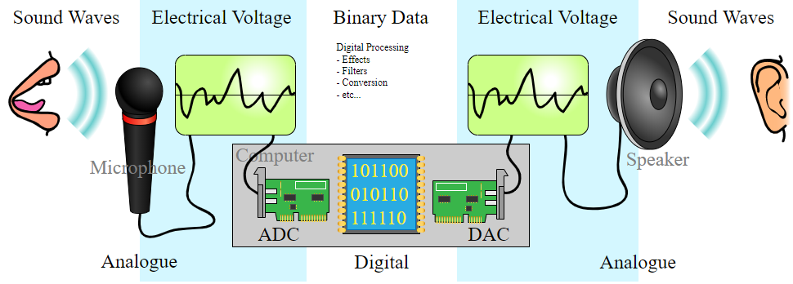

Figure 3 – Analog to digital signals [35]

- Analog to Digital Converter (ADC) - Converts analog sound into digital signals that can be stored on a computer.
- Digital to Analog Converter (DAC) - Converts digital signals stored on a computer into analogue sound that can be played through devices such as speakers

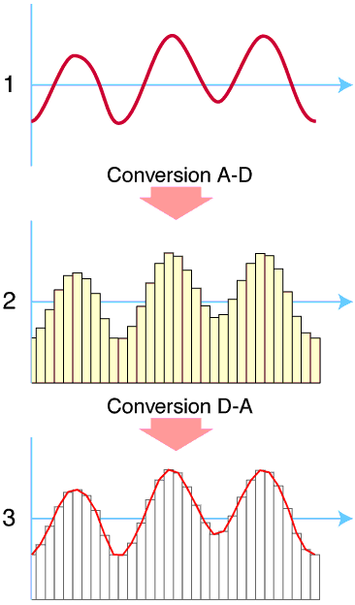

Figure 4 –
(1) The original analog sound wave is a continuous set of points.
(2) ADC converts sound into digital data.
(3) DAC converts digital data into analog sound, the analog wave produced may differ significantly from the original sound wave.

  - Sound Compress
Pulse-code modulation (PCM) [34] is a method used to digitally represent sampled analog signals. It is the standard form of digital audio in computers, compact discs, digital telephony and other digital audio applications. In a PCM stream, the amplitude of the analog signal is sampled regularly at uniform intervals, and each sample is quantized to the nearest value within a range of digital steps.
PCM audio can be encoded in many formats for the end user, and these formats fall into two categories: lossless and lossy.
    - Lossy
Lossy compression enables even greater reductions in file size by removing some of the audio information and simplifying the data. This, of course, results in a reduction in audio quality, but a variety of techniques are used, mainly by exploiting psychoacoustics, to remove the parts of the sound that have the least effect on perceived quality, and to minimize the amount of audible noise added during the process. The popular MP3 format is probably the best-known example, but the AAC format found on the iTunes Music Store is also common. Most formats offer a range of degrees of compression, generally measured in bit rate. The lower is the rate, the smaller is the file and the more significant the quality loss.
- Lossy Formats
  - Mpeg Audio Layer 3 – mp3
  - Advanced Audio Coding – AAC
    - Lossless
A lossless compressed format stores data in less space without losing any information. The original, uncompressed data can be recreated from the compressed version.
Uncompressed audio formats encode both sound and silence with the same number of bits per unit of time. Encoding an uncompressed minute of absolute silence produces a file of the same size as encoding an uncompressed minute of music. In a lossless compressed format, however, the music would occupy a smaller file than an uncompressed format and the silence would take up almost no space at all.
Lossless compression formats include the common FLAC, WavPack, Monkey's Audio, ALAC (Apple Lossless). They provide a compression ratio of about 2:1 (i.e. their files take up half the space of PCM). Development in lossless compression formats aims to reduce processing time while maintaining a good compression ratio.
- Lossless Formats
  - Waveform Audio File Format – WAV
  - Audio Interchange File Format – AIFF
  - Free Lossless Audio Codec – FLAC
    - What the difference between lossy and lossless compression
During processing, lossless compression rips audio files so that they reduce in size, but no quality is lost. It's a perfect copy of the original sound. You can also convert one lossless format to another without any loss of quality. But the one thing you cannot ever do is convert lossless to lossy, not because it's impossible, it's just a stupid thing to do. For more info, read why converting FLAC to MP3 or WAV vs. MP3 is a terrible thing to do.
On the other hand, lossy compression reduces the size of an original file up to ten times, so 100 MB become 10 MB, but some audio data is irreversibly lost therefore it may sound as if a song lacks something, or the other way round, some sound artifacts can appear.
  - Sound Decompress
Decompression is the process of restoring compressed data to its original form [35]. Data decompression is required in almost all cases of compressed data, including lossy and lossless compression. Similar to compression of data, decompression of data is also based on different algorithms. Decompression is considered important, as compressed data needs to be restored back to standard state for usage. Decompression is widely used in data communications, multimedia, audio, video and file transmissions Decompression is also known as uncompression.
In Fig. 5 below, we can see the overview of the whole transfer process without compressing/decompressing. Compressing the message could be done before the ASCII encoder, and the decompressing should be done after the ASCII decoder.
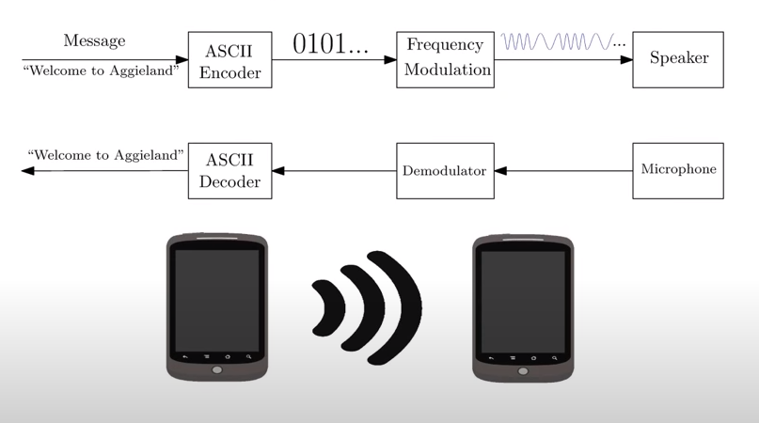

Figure 5 - Overview of the transfer process without compressing/decompressing, cf. [33].
- Example of Data Preparation for Inaudible Transfer
The following is an example of how we prepared a visit card for inaudible transfer.
Suppose we are transferring the visit card in Fig. 6. Let us first look at the ERD diagram corresponding to our database (stored on the device), see Fig. 7.
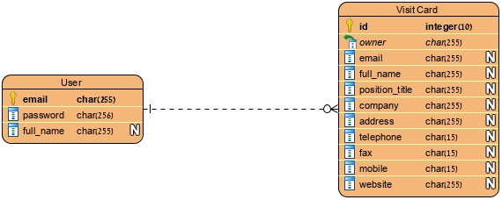
Figure 6 – Travel agent visit card to be sent.

Figure 7 – The ERD diagram of our database

As we can see, visit cards are represented in the database in two relations. In this example, we will focus on the Visit Card relation. The flow of the data preparation is as follows:
- Take the tuple from the database and encode it to a string.
- Compress it.
- Convert the resulted string (compressed or not) to binary form.
- Assign sound frequencies 18KHz and 19KHz for 0’s and 1’s, respectively.
- Create a WAV audio file.
- The visit card is ready for transfer.
For encoding, we conform to the convention that we use a special delimiter character ‘;’, and that values appear in the same order they appear in the ERD (if a value is missing it would simply be ‘;;’).

Figure 8 – The tuple in the database corresponding to the visit card

Following the aforementioned rules and flow of actions. The above tuple, see Fig.8, will be encoded into the following string, as seen in Fig. 9.

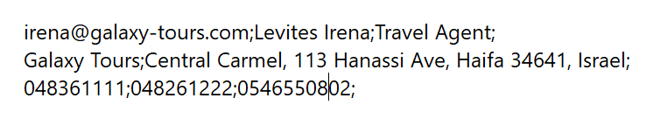
Figure 9 – The string representing the encoded visit card

The above string is too long (224 characters) and needs to be compressed. In fact, we will compress every string to shorten the transfer time. We then feed the compressed string into a function that converts string to binary and get the following binary sequence, as seen in Fig.10.

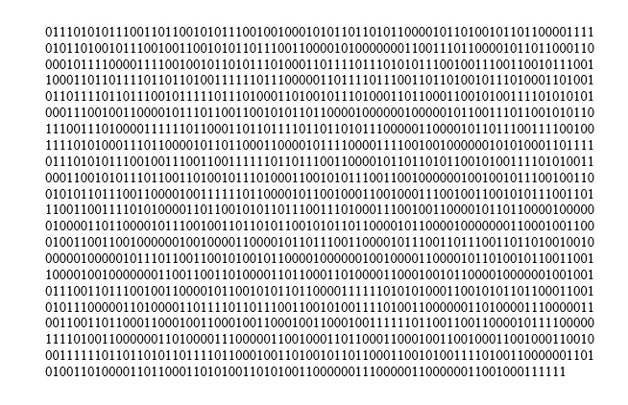
Figure 10 – The binary sequence

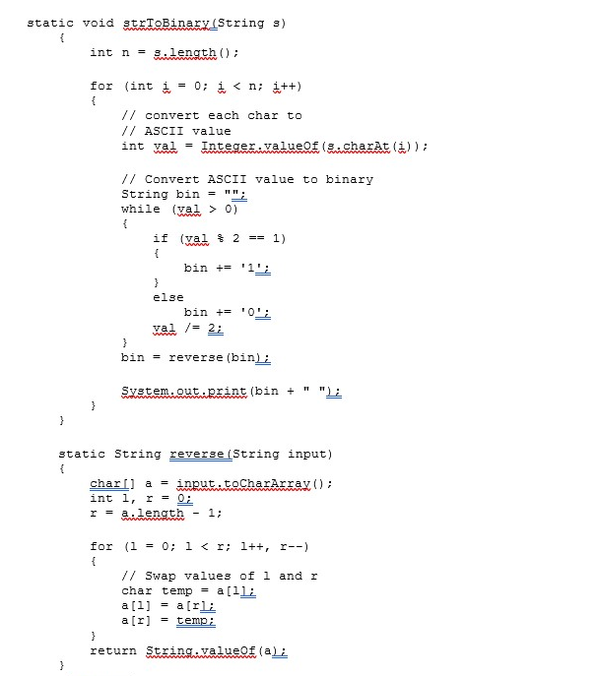
Many functions are at our service for that task. An example of such a function is as follows (in Java), cf. [35]:
Figure 11 – The Java method for converting ASCII to binary

Then, we transfer the binary sequence to the second team for inaudible transmission to another device. Physically, the binary sequence is stored locally on the device memory in a buffer.
- General Flow of Data Preparation for Inaudible Transfer
  - Get the visit card tuple from the local database.
The first step in the data preparation, after the user clicks on send, is to get the visit card tuple from the database which is stored in the visit card relation.
  - Encode tuple to a string (with delimiter)
After we get the visit card tuple from the database, our objective is to encode it into a string. To do so, both teams must agree on a convention that the special delimiter character is ‘;’. The encoding process, or the string building process if you will, is as follows:
- Write the values of the attributes in the order they appear in the ERD and separate each value with ‘;’, if a value is missing (i.e. it was not provided in the visit card) then simply put an empty string in its place (the encoding in that place becomes ‘;;’). Putting just the values in the encoding yields a shorter string and our motto is “the shorter the better”.
- After we get a string encoding, from the encoding process we just described, that represents the database tuple. We compress it to make it smaller in size. The compression process is crucial to make the broadcasting process shorter. For the compression algorithm, we will need a lossless compression algorithm since every bit of data is important in our case. After some research, we found out that any LZ-based compression algorithm, cf. [36], will do the job well. However, we hope that any algorithm that brings the binary representation to a shorter length will work as well.
  - Convert a string to binary
Our main objective now is to convert the resulted string to a binary sequence. Doing that takes little to no time since many programming languages offer a library that does such a job, and if not, it is not hard to write one of our own. Since Android applications are developed in Java, we will use the method in Java, shown on Fig. 8 above.
  - Transmit a binary sequence
Now, the binary sequence is in hand: it is stored locally in the device memory in a buffer. The second team is responsible for transmitting it to the receiving smartphone. So, all we must do in this step is pass the binary sequence to the appropriate method provided by the second team.

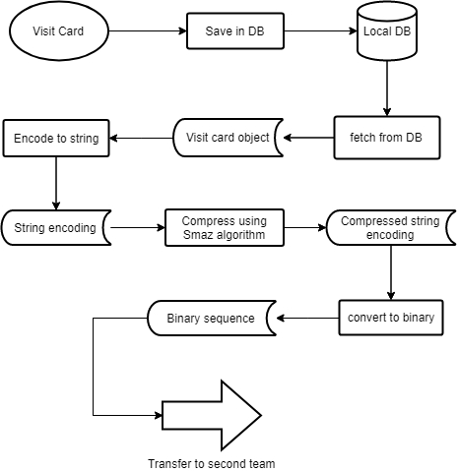
The below Fig. 12, shows the flowchart of the sending process.
Figure 12 – The flowchart of the sending process

  - Receive a binary sequence from second team
We are now in the receiving smartphone. We got the binary sequence from the second team and can assume that it is noise-free and errorless. It is stored locally on the device memory in a buffer.
  - Convert to ASCII
Now, our intent is to convert the binary sequence into something more readable. To achieve that, we split it into blocks of 8-bits each; and convert each block to the corresponding ASCII code. Eventually, we will get a string.
  - Decompress & Decode to database tuple
Before we decode, we must decompress. It is obvious that the decompression process must correspond to the compression process (corresponding algorithm).
After that, we split the string by the special delimiter character ‘;’ and get a meaningful database tuple in the form of value1; value2;….
  - Save the visit card.
We are here, the final step. Now we must save the visit card. We extract the value for each attribute and create a database tuple and save it. We are also going to save the visit card in the phonebook, we can do that with the proper permissions from the user which we will ask for when the user downloads and installs the application.
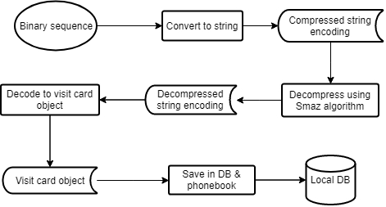
The below figure, Fig. 13, shows the flowchart of the receiving process.
Figure 13 – The flowchart of the receiving process
- Difficulties and How We Overcame Them
In the time span of our project, we faced several problems.
Firstly, when we started the implementation phase, we had a concern based on the lack of our understanding of the development environment and how to write applications for Android OS, we overcame this difficulty by carefully reading the Android documentation, cf. [1], which thoroughly explains the development environment and how to write applications for Android OS.
The second difficulty we faced was data transmission. The question was how to manage the data passing through the app from screen to screen. Especially when said data would be exceptionally large.
e.g., when passing a visit card data from the Home page to the View Visit Card page, a single visit card consists of 11 fields, and taking into consideration that passing a single field requires writing 5 lines of code we get that passing 11 fields would require approximately 55 lines of code. And let us not forget that passing those 11 fields from those two pages is not the only place we have to do that, which would make our code quite verbose, something that is not considered as good practice. In fact, it is frowned upon in most workplaces.
We thought to ourselves, are we the first people to be faced with such a problem? As it turned out, we were not. In fact, this is a very well-known problem in software engineering among many others and four people by the names Erich Gamma, Richard Helm, Ralph Johnson, and John Vlissides have gathered them and their solutions in a book called Design Patterns [37].
The solution to our problem was creating a DTO (Data Transfer Object) [38] class for each entity we pass between screens or to functions. A DTO is a POJO (Plain Old Java Object) [39] which consists of just the fields required and getters & setters [40], to pass a large number of fields as arguments to a function or to a different page in the app we simply encapsulate them in a DTO and pass that as the argument, thus adhering to those 5 lines of code (sometimes even less) and preventing the code form being verbose.
After that we were faced with a related problem, the constructor call of said DTO was rather lengthy and error prone, e.g., one might not pass the correct number of arguments to the constructor. The question was how to make the code more readable and less error prone? Design patterns to the rescue!
The Builder design pattern [41] is a perfect solution to our problem, though the paper will not focus on its’ working and implementation process. In short, it is an inner static class and object creation is done through a series of setter calls. If needed, further reading is available for readers on external sources.
Using the Builder design pattern has prevented common errors and substantially improved the readability of our code, albeit it is a bit more verbose now.
Another slightly less related problem was what to do if we want instance methods other than the getters & setters? As it is known, POJO classes cannot contain methods other setters & getters. So once again, design patterns to the rescue!
You cannot say DTO without DAO (Data Access Object) [42] coming to mind, a DAO is simply a mediator between the database and the application. By using DAO, we created a mediator between the DTO and other parts of the application, including the database.
The third difficulty we faced was how to compress the string and get a significantly shorter string. We needed a string that will reach high compression percentage on every string length. At first, we tried the traditional Java.util.zip library [43], which includes the Deflater, and GZIP methods [44]. All those methods reached up to %70 space saving but only on longer strings, i.e., on strigs longer than ~400 characters. We needed a better approach, so we did some more research and came upon a group of compression algorithms called LZ compression algorithms, cf. [36], they are mainly used in JavaScript language where it is common to store strings in the Local Storage [45] which is limited to storing only 5MB of data. One specific algorithm we came upon can reach up to 54% space saving for all string lengths, which will work perfect for our case because most strings we produce are considerably short. Another problem, which we faced, was that those algorithms are written in JavaScript and we needed to “translate” them to Java. Fortunately, we came upon a repository in GitHub [46] full of “translations” of those algorithms to many languages including Java [47].
However, our difficulty did not end there. We still had to consider the binary representation length. In Java, strings are encoded in UTF-16 [48], which means, after (or before) compression, each character is 16 bits long. It is not good for our purpose because no matter how short the compressed string is the binary representation will be lengthy. After all, our goal is to transmit as less bits as possible to achieve faster data transmission.
So, we continued our researched and came upon another compression algorithm called Smaz [49]. Although Smaz is not LZ-based, it comes to solve a common problem with all LZ-based algorithms, which is compressing small strings (up to a hundred bytes or so) by searching for common words in the English language and compressing them into one byte (using a codebook). For example, the word ‘the’ is very common so it gets compressed into one byte. What is special about Smaz is that works with ASCII encoded strings and returns a result that is also encoded in ASCII which makes our binary representation significantly shorter than before.
We conducted a small experiment to compare between different compression algorithms by compressing a string representing a typical visit card of length 142.
The string is: “jaraisy.fares@gmail.com;fares jaraisy;software engineer;optima;Nazareth 6060, 1605413, Israel;0522443361;046465001;046465001;www.optima-da.com”.
See table of performance comparison below (Table 1).

Compression Algorithm | Compressed String length | Compression ratio | Space Saving
LZString | 64 | 2.2188 | %54.93
Smaz | 121 | 1.1736 | %14.79
Java Deflater & Inflater | 1024 | N/A | N/A
Java GZIP | 133  Table 1 - Comparison between different compression algorithms | 1.0677 | %6.34

As we can see from the table, LZString reached great amounts of space saving while Smaz did not. As for Deflater & Inflater the statistics are not even applicable because the compressed result is longer than the original string. And GZIP did not do well either.
Although the space saving in Smaz is relatively lower than LZString we opted to use Smaz because of the shorter binary representation. We calculated the statistics using a well-known formula [50].

- Results and Conclusions
After all this hard work and research, we obtained a fully functional Android application that successfully connects to a local database and possesses the following abilities:
      - Viewing all stored visit cards.
      - Adding (create new and/or receiving via sound), removing, editing existing visit cards.
      - Preparing a visit card to be transferred over ultrasound, as explained in the previous sections.
      - Receiving a visit card via ultrasound and saving it to the database and the phonebook.
      - User login and register.
      - Change user password.
- Preliminary Software Engineering
  - Requirements:
    - Application views:
In our application, the user can manage visit cards on her/his mobile device, create new visit cards, edit existing ones, and send/receive ones via voice-based transfer.
- Login activity:
Description: Login into the application.
Input: email and password.
Output: If the person exists in the DB, logging into the application. Otherwise, in case of any error an alert message will pop up.

- Register activity:
Description: The user can register with username and password.
Input: full name, email, password, password confirmation.
Output: If the username does not exist in the DB, the user will be added to the DB. Otherwise, if the email already exists, a pop-up message with a request to choose another email will appear. In case of any error, e.g., weak password, name containing non-alphabetical characters, or passwords do not match; an alert message will pop up with a detailed description of the problem.
- Main activity:
Description: The main screen of the application, where the user can see the visit cards received from other users. So, the user can manage them.
Input: The user chooses a desired option.
Output: The user redirected to the suitable screen to her/his choice.
- Create New Visit Card activity:
Description: The user creates new visit card. Upon creating the new visit card, the user can fill the visit card’s attributes.
Input: prefix, first name, middle name, last name, mobile, position, company, email, address, telephone, fax, website. Fields marked with bold are mandatory.
Output: If one or more of the mandatory fields are empty a pop-up message will appear. And if one or more of the inputs is invalid, a pop-up message will appear as well. Upon pressing the save button, the visit card will be saved to the local DB and to the phonebook. If no errors occur in the process the user will be directed to the Main screen.
- Edit Visit Card activity:
Description: The user can view or modify her/his visit card’s attributes.
Input: The user can choose a desired attribute(s) to change.
Output: Upon clicking the “Confirm” button, if the entered attribute(s) are legal, the new data will be saved to the DB, and a success message will pop up. Otherwise, if one of the attribute(s) is illegal, a pop-up message with a request to correct the suitable field(s) will appear.

- Delete Visit Card activity:
Description: The user can delete her/his visit card.
Input: The user can choose the visit card that he/she wants to delete.
Output: Upon clicking the “Delete” button, all the info about this visit card will delete from the DB.

- Send Visit Card activity via sound:
Description: The user can send her/his visit card to other users.
Input: The user can choose the visit card that he/she wants to send.
Output: Upon clicking the “Send” button, the sending process detailed in previous sections will occur.

- Receive Visit Card activity:
Description: The user can receive visit card from another users.
Input: None.
Output: Upon clicking the “Receive via sound” button, the receiving process detailed in previous sections will occur.

- Change Password activity
Description: The user can change her/his password.
Input: new password, confirm new password.
Output: If the old password does not match the one in the DB, an error message will pop up. If the new password does not match the confirmed new password, then an error message will pop up as well. If all goes well, the new password will be updated in the DB, and a success message will appear.

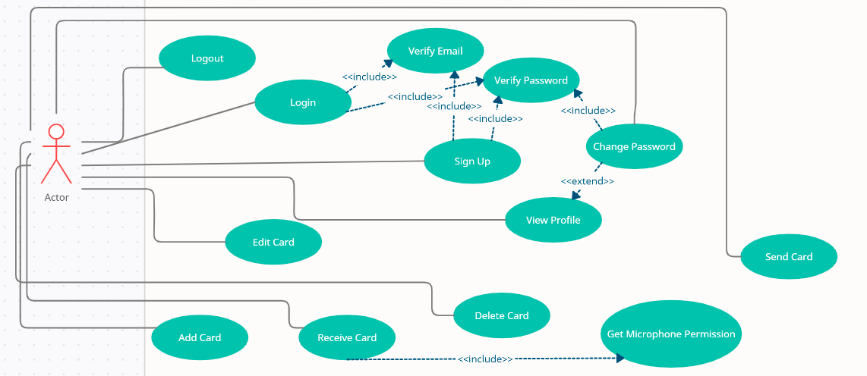
  - Use Case Diagram
Fig. 14: Use Case Diagram

  - Design (GUI, UML diagrams)
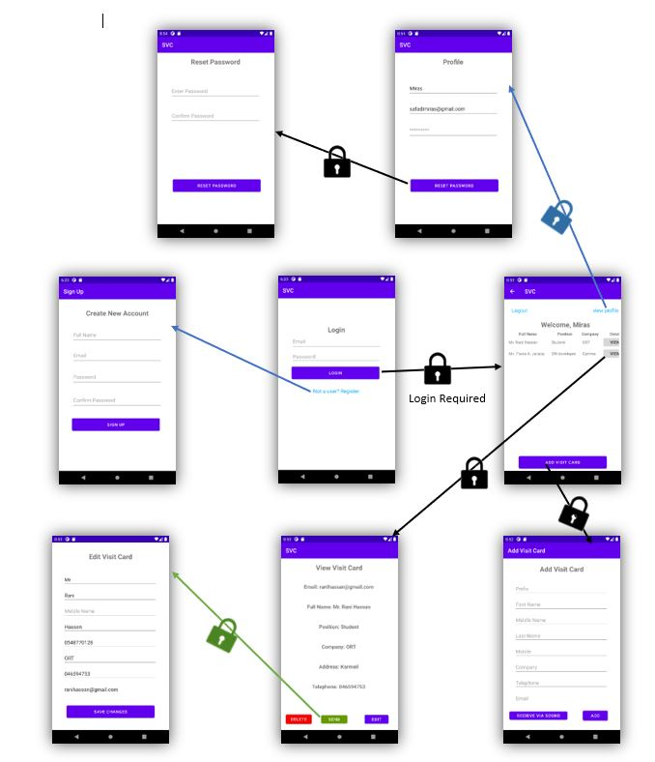
    - GUI
Figure 15 - The flow of Activities of the application

    - Class Diagrams
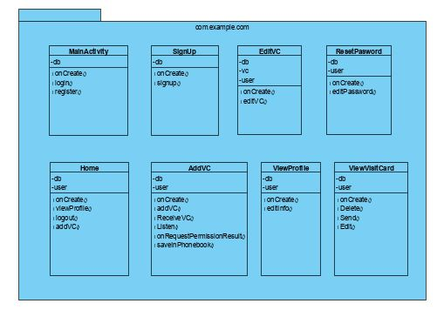
Fig. 16: Activities Package
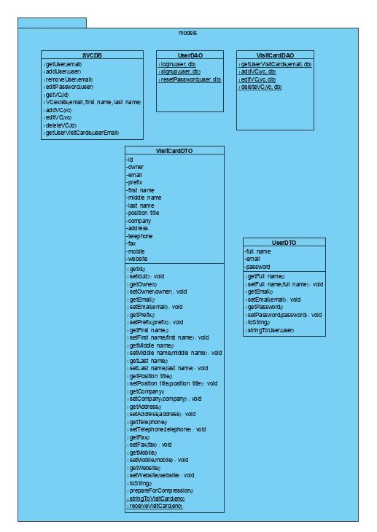
Fig. 17: Models Package
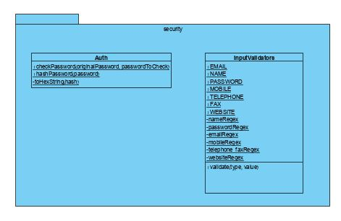
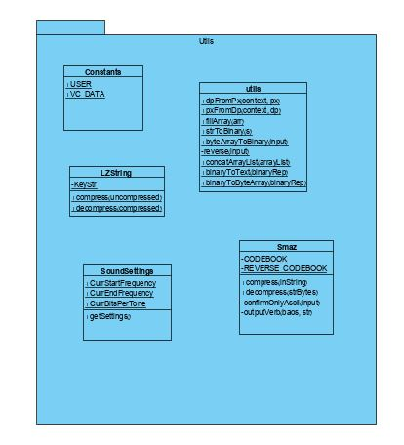
Fig. 18: Security & Utils Package
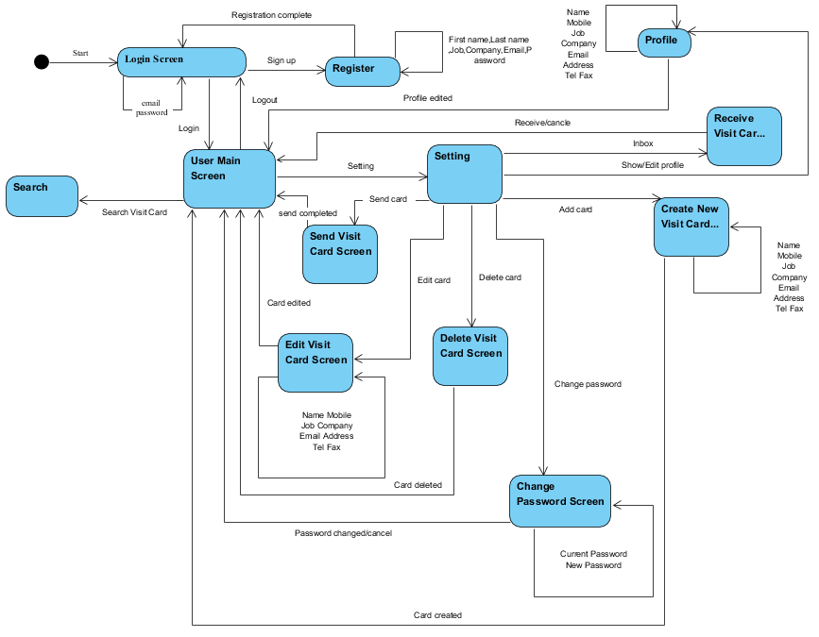
    - Activity Diagram
Fig. 19: Activity Diagram

  - Testing plan
We tested all input fields by validating them against a REGEX.
    - Login
Table 2: Testing plan- Login
Test ID | Initiating actor | Description | Expected results | Results
Successful Login | User | The user entered correct Email and password and pressed “login” button. | The "SVC" application is displayed. | Pass – The Home page is displayed.
User Email Does Not Exist | User | The user entered wrong Email which is not in DB and pressed “login” button. | An error message will be shown: “Username not exists”. | Pass – “Incorrect credentials” alert is displayed
Incorrect Password | User | The user entered a username with wrong password and pressed “login” button. | An error message will be shown: “Invalid login!”. | Pass – “Incorrect credentials” alert is displayed
Empty Email Field | User | The user did not enter username and pressed “login” button. | An error message will be shown: “Insert your Email”. | Pass – “One or more of the fields is missing” alert is displayed.
Empty Password Field | User | The user did not enter password and pressed “login” button. | An error message will be shown: “Insert your Password”. | Pass – “One or more of the fields is missing” alert is displayed.

    - Register
Test ID | Initiating actor | Description | Expected results | Results
Successful Registration | Unregistered user | The user fills all mandatory fields correctly. | The user will be added to DB and a message will be shown: “Registration completed”. | Pass – “Successfully registered” alert is displayed.
Empty Name Field | Unregistered user | The user didn’t enter name and pressed “register” button. | An error message will be shown: “Mandatory field, please insert your name”. | Pass – “One or more of the fields is missing” alert is displayed.
Empty Password Field | Unregistered user | The user did not enter password and pressed “register” button. | An error message will be shown: “Mandatory field, please insert password”. | Pass – “One or more of the fields is missing” alert is displayed.
Empty Email Field | Unregistered user | The user did not enter email and pressed “register” button. | An error message will be shown: “Mandatory field, please insert your email”. | Pass – “One or more of the fields is missing” alert is displayed.
Invalid Picture | Unregistered user | The user chose a wrong file format as a profile picture. | An error message will be shown: “File format not supported”. | Fail – We did not implement adding profile pictures due to the short time frame.
Email Exists | Unregistered user | The user chose an email that is already in use. | An error message will be shown: “Username is occupied, please choose another”. | Pass – “Email exists” alert is displayed.
Confirm Password Field | Unregistered user | The user entered 2 passwords that do not match. | An error message will be shown: “passwords do not match”. | Pass – “passwords do not match” alert is displayed.
Weak Password | Unregistered user | The user entered a weak password. i.e., NOT meeting the conditions: at least 8 characters long, contains numbers, small and capital letters. | An error message will be shown: “Password must be at least 8 characters long, contains numbers, small and capital letters.” | Pass - “Password must be at least 8 characters long and contain at least 1 digit, 1 small case letter, and 1 upper case letter” alert is displayed
Table 3: Testing plan- Register
    - Create a New Visit Card
Test ID | Initiating actor | Description | Expected results | Results
Successful Creating | User | The user fills all mandatory fields correctly. | The new visit card will be added to DB and a message will be shown: “Creating completed”. | Semi-Pass – No alert is shown but the user is taken back to the home page.
Empty Name Field | User | The user did not enter name and pressed “create” button. | An error message will be shown: “Mandatory field, please insert your name”. | Pass – “Mandatory fields missing” alert is displayed.
Empty Job Field | User | The user did not enter job and pressed “create” button. | An error message will be shown: “Mandatory field, please insert your job”. | Pass – “Mandatory fields missing” alert is displayed.
Empty Email Field | User | The user did not enter email and pressed “create” button. | An error message will be shown: “Mandatory field, please insert your email”. | Pass – “Mandatory fields missing” alert is displayed.
Invalid Name | User | The user entered an invalid name and pressed “create” button. i.e., NOT containing only English letters. | An error message will be shown: “Name must contain only English letters”. | Pass – “Invalid name, it must contain only English letters” alert is displayed.
Invalid Email | User | The user entered an invalid email and pressed “create” button. | An error message will be shown: “Email is invalid”. | Pass – “Invalid email” alert is displayed.
Table 4: Testing plan- Create new visit card
בב

    - Edit a Visit Card
Test ID | Initiating actor | Description | Expected results | Results
Successful Editing | User | The user fills all mandatory fields correctly and modifies other attributes as he/she wants. | The visit card will be updated in DB and a message will be shown: “Editing completed”. | Semi-Pass – no alert is shown, but the user is taken back to the home page.
Empty Name Field | User | The user did not enter name and pressed “edit” button. | An error message will be shown: “Mandatory field, please insert your name”. | Pass – “Mandatory fields missing” alert is displayed.
Empty Job Field | User | The user did not enter job and pressed “edit” button. | An error message will be shown: “Mandatory field, please insert your job”. | Pass – “Mandatory fields missing” alert is displayed.
Empty Email Field | User | The user did not enter email and pressed “edit” button. | An error message will be shown: “Mandatory field, please insert your email”. | Pass – “Mandatory fields missing” alert is displayed.
Invalid Name | User | The user chose an invalid name and pressed “edit” button. | An error message will be shown: “Name must contain only English letters”. | Pass – “Invalid name, it must contain only English letters” alert is displayed.
Invalid Email | User | The user entered an invalid email and pressed “edit” button. | An error message will be shown: “Email is invalid”. | Pass – “Invalid email” alert is displayed.
Table 5: Testing plan- Edit visit card
    - Edit User Profile
Test ID | Initiating actor | Description | Expected results | Results
Successful Editing | User | The user fills all mandatory fields correctly and modifies other attributes as he/she wants. | The user will be updated in DB and a message will be shown: “Editing completed”. | Semi-Pass – no alert is shown, but the user is taken back to the home page.
Empty Name Field | User | The user didn’t enter name and pressed “edit” button. | An error message will be shown: “Mandatory field, please insert your name”. | Fail – We did not add the option of editing the name.
Empty Job Field | User | The user didn’t enter job and pressed “edit” button. | An error message will be shown: “Mandatory field, please insert your job”. | Fail – We did not add a Job field to the User table in the DB.
Empty Email Field | User | The user didn’t enter email and pressed “edit” button. | An error message will be shown: “Mandatory field, please insert your email”. | Fail – We did not add the option of editing the email.
Invalid Name | User | The user chose an invalid name and pressed “edit” button. | An error message will be shown: “Mandatory field, please insert your email”. | Fail – We did not add the option of editing the name.
Invalid Email | User | The user entered an invalid email and pressed “edit” button. | An error message will be shown: “Email is not match”. | Fail – We did not add the option of editing the email.
Table 6: Testing plan- Edit user profile
    - Change Password
Test ID | Initiating actor | Description | Expected results | Results
Invalid New Password | User | The user entered a new password which length is less than six. | An error message will be shown: “Password length must be at least 8 characters, contain numbers and small & upper-case letters”. | Pass - “Password must be at least 8 characters long and contain at least 1 digit, 1 small case letter, and 1 upper case letter” alert is displayed
Password confirmation does not match | User | The user entered confirm password which does not match to the new password and pressed “save” button. | An error message will be shown: “Confirm password doesn’t match to new password”. | Pass – “passwords do not match” alert is displayed.
Wrong Old Password | User | The user entered wrong old password and pressed “save” button. | An error message will be shown: “Old password is incorrect”. | Fail – We did not add this field.
Empty New Password Field | User | The user did not enter new password and pressed “save” button. | An error message will be shown: “New password is mandatory”. | Pass – “One or more of the fields is missing” alert is displayed.
Empty Confirm Password Field | User | The user did not enter confirm password and pressed “save” button. | An error message will be shown: “Confirm password is mandatory”. | Pass – “One or more of the fields is missing” alert is displayed.
Empty Old Password Field | User | The user did not enter old password and pressed “save” button. | An error message will be shown: “Old password is mandatory”. | Fail – We did not add this field.
Table 7: Testing plan- Change password
- References
[1] Android OS official documentation: https://developer.android.com/docs
[2] The websites we visited for help and guidance: https://stackoverflow.com/, tutorialspoint.com/android/index.htm
[3] SQLite: https://en.wikipedia.org/wiki/SQLite
[4] Smartphones: https://en.wikipedia.org/wiki/Smartphone
[5] Visit Cards: https://en.wikipedia.org/wiki/Business_card
[6] API: https://www.igi-global.com/dictionary/test-template-data-mining-publications/1298
[7] Distributed system architecture: https://en.wikipedia.org/wiki/Distributed_computing
[8] Client-Server architecture: https://en.wikipedia.org/wiki/Client%E2%80%93server_model
[9] Android OS: https://en.wikipedia.org/wiki/Android_ (operating system)
[10] Mobile operating system: https://en.wikipedia.org/wiki/Mobile_operating_system
[11] Linux kernel: https://en.wikipedia.org/wiki/Linux_kernel
[12] Android TV: https://en.wikipedia.org/wiki/Android_TV
[13] Android Auto: https://en.wikipedia.org/wiki/Android_Auto
[14] Android Wear: https://en.wikipedia.org/wiki/Wear_OS
[15] Android and SQLite: https://www.tutorialspoint.com/android/android_sqlite_database.html
[16] Android services: https://developer.android.com/guide/components/services.html
[17] Mobile app: https://en.wikipedia.org/wiki/Mobile_app
[18] Android permissions: https://developer.android.com/guide/topics/permissions/overview
[19] Facebook API:https://www.researchgate.net/publication/272356903_Building_Applications_with_Social_Networking_API's
[20] PHP: https://www.php.net/manual/en/intro-whatis.php
[21] SQL: https://en.wikipedia.org/wiki/SQL
[22] How Smartphones transfer data via sound? https://www.electronicdesign.com/industrialautomation/article/21808186/sending-data-over-sound-how-and-why
[23] Quick Response Code – https://en.wikipedia.org/wiki/QR_code
[24] Voice over Internet Protocol – https://en.wikipedia.org/wiki/Voice_over_IP
[25] Audio file types – https://www.canto.com/blog/audio-file-types/
[26] AIFF – https://www.abyssmedia.com/formats/aiff-format.shtml
[27] PCM Sound – https://en.wikipedia.org/wiki/Pulse-code_modulation
[28] String to binary function: https://www.geeksforgeeks.org/convert-string-binary-sequence/
[29] Compression: https://www.bbc.co.uk/bitesize/clips/zc2svcw
[30] Decompression: https://www.techopedia.com/definition/14330/decompression
[31] LZ77 and LZ78: https://en.wikipedia.org/wiki/LZ77_and_LZ78
[32] Sliding window: https://en.wikipedia.org/wiki/Sliding_window_protocol
[33] Overview of the transfer process - https://www.youtube.com/watch?v=kb_e3DPPdsU
[36] LZ compression algorithm - https://www.anandtech.com/show/218/2
[37] Design Patterns: https://en.wikipedia.org/wiki/Design_Patterns
[38] DTO Design Pattern: https://www.tutorialspoint.com/design_pattern/transfer_object_pattern.htm
[39] POJO - https://en.wikipedia.org/wiki/Plain_old_Java_object
[40] Getters and Setters - https://www.w3schools.com/java/java_encapsulation.asp
[41] Builder Design Patter: https://en.wikipedia.org/wiki/Builder_pattern
[42] DAO Design Pattern - https://en.wikipedia.org/wiki/Data_access_object
[43] Java.util.zip library - https://docs.oracle.com/javase/8/docs/api/index.html?java/util/zip/package-summary.html
[44] Deflater, GZIP, and ZIP - https://docs.oracle.com/javase/8/docs/api/java/util/zip/Deflater.html, https://docs.oracle.com/javase/7/docs/api/java/util/zip/GZIPInputStream.html
[45] JavaScript Local Storage API - https://developer.mozilla.org/en-US/docs/Web/API/Window/localStorage
[46] GitHub - https://en.wikipedia.org/wiki/GitHub
[47] LZString4j repository - https://github.com/diogoduailibe/lzstring4j
[48] UTF-16 - https://en.wikipedia.org/wiki/UTF-16#:~:text=UTF%2D16%20(16%2Dbit,two%2016%2Dbit%20code%20units.
[49] Smaz – https://github.com/RyanAD/jsmaz
[50] Compression statistics - https://en.wikipedia.org/wiki/Data_compression_ratio

